

MASENO 2025 KCSE PREDICTION
CONFIDENTIAL EXAM
233/1
CHEMISTRY
PAPER 1 (THEORY)
TIME: 2 HOURS

NAME……………………………………………………………………………………….
SCHOOL……………………………………………… SIGN………………………..
INDEX NO……………………………………………. ADM NO……………………

(Kenya Certificate of Secondary Education)

INSTRUCTIONS TO CANDIDATES
  - Write your name and index number in the spaces provided above.
  - Sign and write the date of the examination in the spaces provided above.
  - Answer all the questions in the spaces provided in the question paper.
  - Non-programmable silent electronic calculators and KNEC mathematical tables may be used.
  - All working must be clearly shown where necessary.
  - Candidates should answer the questions in English.

FOR EXAMINER’S USE ONLY
Question | Maximum score | Candidate’s score
1-27 | 80

- State two laboratory rules that should be followed to avoid contamination and wastage of chemicals. (2 marks)
......................................................................................................................
......................................................................................................................
......................................................................................................................

- The figure below shows a flame obtained from a Bunsen burner.
A

B

C

- Name the type of flame. (1 mark)
......................................................................................................................
- A matchstick head placed at region C will not ignite. Explain. (1 mark)
......................................................................................................................
......................................................................................................................
- Name region A. (1 mark)
......................................................................................................................

- In the last stage of the Solvay process a mixture of sodium hydrogen carbonate and ammonium chloride is formed.
- State the method of separation used. (1 mark)
......................................................................................................................
- Write an equation showing how lime is slaked. (1 mark)
......................................................................................................................

- Name the by - products recycled in the above process. (1 mark)
......................................................................................................................

- The following is a list of bond energies.
Bond | Energy kJ/mol
C – C | 348
C = C | 612
Cl Cl | 242
C Cl | 338
Calculate the enthalpy change for the following reaction. (3 marks)
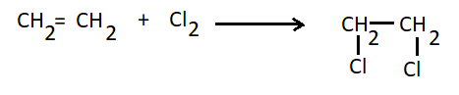
......................................................................................................................
......................................................................................................................
......................................................................................................................

- The equation below represents an equilibrium between chromate ions Cr₄O²⁻ and dichromate ions Cr₂O₇²⁻
2Cr₄O²⁻_{(aq)}+ 2H⁺_{(aq)} Cr₂O₇²⁻ _{(aq)}+H₂O_{(l)}
Yellow Orange
State what would happen to the position of the equilibrium reaction if dilute sodium hydroxide solution is added to the mixture. Give a reason for your answer. (2 marks)
......................................................................................................................
......................................................................................................................
......................................................................................................................

- The table below gives some physical properties of substances D, E and F. Study it and answer the questions that follow;
Substance | M.P (ºC) | Solubility in water | Electrical conductivity
 |  |  | Solid | Liquid
D | 3700 | Insoluble | Non conductor | Non-conductor
E | 801 | Soluble | Non conductor | Conductor
F | 1083 | Insoluble | Conducts | Conducts

Identify the substance that has ;
(i) Giant atomic structure (1 mark)
......................................................................................................................
(ii) Giant Ionic structure (1 mark)
......................................................................................................................
(iii) Metallic bonding (1 mark)
......................................................................................................................

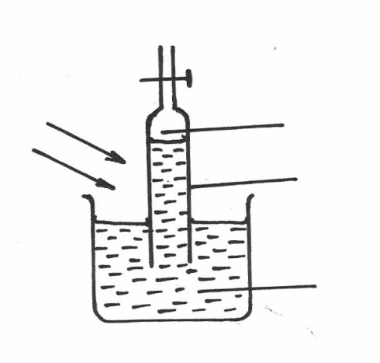
- An experiment was set up using chlorine water as shown below;
Gas G

Burette

Chlorine water

Sunlight

(i) Identify gas G (1 mark)
......................................................................................................................

(ii) Write an equation for the production of gas G (1 mark)
......................................................................................................................

- Study the diagram below and answer the questions that follow. The diagram shows the method of separating components of mixture Q.
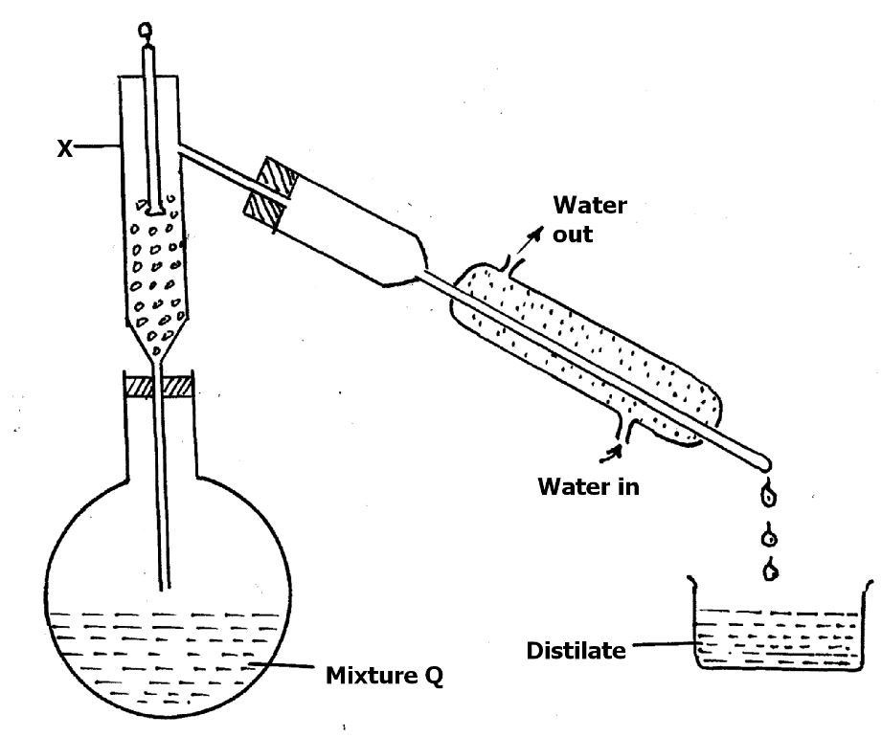

- Name the part labelled X. (1mark)
......................................................................................................................
- State what would happen if the water inlet and water outlet in the Liebig’s condenser is interchanged. (1mark)
......................................................................................................................
......................................................................................................................

- Element J with atomic number 12 and L with atomic number 9.
(a) To which chemical family is; (2 marks)
J - ………………………………………………………………………
L - ………………………………………………………………………

- Write the equation for the reaction between J and L. (1 mark)
......................................................................................................................

- Carbon and silicon are group IV elements. At room temperature, carbon (IV) oxide exists as a gas while silicon (IV) oxide exists as a solid. Explain this observation in terms of structure and bonding. (2 marks)
......................................................................................................................
......................................................................................................................
......................................................................................................................
......................................................................................................................

- Study the diagram below and answer the questions that follow.
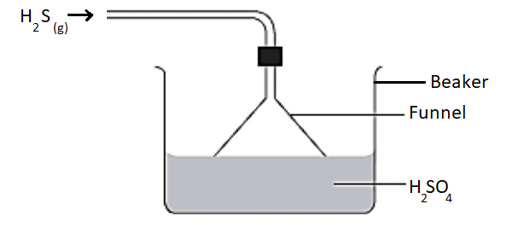

- Give the observation made in the beaker. (1 mark)

......................................................................................................................
......................................................................................................................

- Write an equation for the reaction that took place in the beaker. (1 mark)
......................................................................................................................
......................................................................................................................

- Give one reason why the gas is directed into the beaker using the inverted funnel
as above? (1 mark)
......................................................................................................................
......................................................................................................................

- a) Define solubility. (1 mark)
......................................................................................................................
......................................................................................................................

b) The following results were obtained during an experiment to determine solubility of solid M at 25⁰C;
Mass of evaporating dish = 45.0g
Mass of evaporating dish + saturated solution = 59.0g
Mass of evaporating dish + dry solid B = 53.0g
Calculate the solubility of B at 25⁰C. (2 marks)
......................................................................................................................
......................................................................................................................
......................................................................................................................
......................................................................................................................
......................................................................................................................

- When a hydrocarbon was completely burnt in oxygen, 4.2g of carbon(IV)oxide and 1.71g of water were formed. Determine the molecular formula of the hydrocarbon given that its relative molecular mass is 42. ( H = 1.0, C = 12.0, O = 16.0) (3 marks)
......................................................................................................................
......................................................................................................................
......................................................................................................................
......................................................................................................................

- A mixture of magnesium powder and lead (II) oxide reacts vigorously to form a white residue when heated, but no reaction is observed when a mixture of magnesium oxide and lead powder is heated.
a) Explain this observation. (2 marks)
......................................................................................................................
......................................................................................................................
......................................................................................................................

b) Write a chemical equation for the reaction of magnesium powder and lead (II) oxide (1 mark)
......................................................................................................................

c) In the reaction above, identify:
The reducing agent (1 mark)
......................................................................................................................

The oxidized species (1 mark)
......................................................................................................................

- During laboratory preparation of ethane gas, solid N was mixed with soda lime and heated .
a) Identify solid N. (1 mark)
......................................................................................................................

b) Give one reason why soda lime is preferred to pure sodium hydroxide pellets in this experiment. (1 mark)
......................................................................................................................
......................................................................................................................

c) State one use of ethane gas. (1 mark)
......................................................................................................................
......................................................................................................................

- (a) State Graham’s law of diffusion. (1 mark)
......................................................................................................................
......................................................................................................................

(b) 20cm³ of hydrogen chloride gas diffuses through a porous pot in 20seconds. How long would it take 40cm³ of Sulphur (IV) oxide gas to diffuse through the same pot under the same conditions (H =1 Cl = 35.5 S = 32 O =16) (2 marks)
......................................................................................................................
......................................................................................................................
......................................................................................................................
......................................................................................................................

- a) When gases are required dry, they are collected after passing them through a drying agent. Identify the suitable drying agents for the following gases; (2 marks)
GAS | SUITABLE DRYING AGENT
Ammonia
Hydrogen sulphide

b) State one use of ammonia. (1 mark)
......................................................................................................................
......................................................................................................................

- Describe how to experimentally separate a mixture of lead(II)chloride and zinc carbonate.
(2 marks)
......................................................................................................................
......................................................................................................................
......................................................................................................................
......................................................................................................................

- Using dots(.) and crosses (x) show how magnesium combines with oxygen to form magnesium oxide. ( Mg = 12, O = 8) (2 marks)
......................................................................................................................
......................................................................................................................
......................................................................................................................
......................................................................................................................
......................................................................................................................

- Equal masses of liquid dinitrogen tetraoxide and liquid ammonia are warmed to form gases independently at room temperature and pressure. State and explain the gas which will occupy greater volume. (N = 14, H = 1, O = 16) (2 marks)
......................................................................................................................
......................................................................................................................
......................................................................................................................
......................................................................................................................

- a) Define allotropy. (1 mark)
......................................................................................................................
......................................................................................................................
b) Name the allotropes of sulphur. (1 mark)
......................................................................................................................
......................................................................................................................
c) Which allotrope of carbon conducts electricity. (1 mark)
......................................................................................................................

- The structures below represent two cleansing agents: U and V
U : R – COO⁻ Na⁺
V : R – OSO₃⁻Na⁺
- Identify the class of cleansing agents to which U belongs. (1 mark)
......................................................................................................................

- Which cleansing agent is suitable for use with water which contains Ca²⁺ ions? Explain. (1mark)
......................................................................................................................
......................................................................................................................

c) State one disadvantage of usage of compound V. (1 mark)
......................................................................................................................

- Study the table below showing pH of certain solutions and use it to answer the questions that follow;
SOLUTION | pH
S1 | 13.0
S2 | 3.0
S3 | 7.0
S4 | 8.5

a) In which of the solutions will phenolphthalein be colourless. (1 mark)
......................................................................................................................

b) Which of the solutions can be used to relieve heart burn? Explain. (2 marks)
......................................................................................................................
......................................................................................................................
......................................................................................................................

- When excess magnesium powder was added to 100 cm³ of 0.5M copper(II)sulphate solution, the temperature changed from 25⁰C to 31⁰C.
a) Apart from the rise in temperature, state two other observations made. (1 mark)
......................................................................................................................
......................................................................................................................

b) Calculate the molar heat of displacement for this reaction. (Density of water 1 g/cm³, specific heat capacity of water = 4.2J/g/K) (2 marks)
......................................................................................................................
......................................................................................................................
......................................................................................................................

- The table below gives some properties of gas W and Y.
Gas | Density | Effect on H₂SO₄ | Effect on NaOH
W | Lighter than air | React to form salt | Dissolve without reacting
Y | Heavier than air | Not affected | Not affected
- Describe how you would obtain a sample of dry gas Y from the mixture of gas W and Y. (2 marks)
......................................................................................................................
......................................................................................................................
......................................................................................................................

- Suggest a possible identity of gas W. Give reasons for your answer. (2 marks)
......................................................................................................................
......................................................................................................................
......................................................................................................................

- (a) Using an equation show how an electron can be generated from a neutron. (1 mark)
......................................................................................................................
......................................................................................................................

(b) The table below gives the rate of decay of a radioactive element Z.
Number of days | Mass in g
0 | 48.0
270 | 1.5

Calculate the half-life of the radioactive element Z. (2 marks)
......................................................................................................................
......................................................................................................................
......................................................................................................................

c) State one application of radioactivity in food industry. (1 marks)
......................................................................................................................
......................................................................................................................

- In an experiment, various volumes of 1M sodium iodide solution were added to the same volume of 1M lead (II) nitrate solution. The heights of the precipitate were measured and plotted against volume of 1M sodium iodide used. The graph below was obtained.

28

24
Height of ppt (cm)

20

16

12

8

4

0 2 4 6 8 10 12 14 16
Volume of sodium iodide (NaI) in cm³

  - State the observation made when sodium iodide solution is mixed with lead (II) nitrate solution. (1 mark)
......................................................................................................................
......................................................................................................................

  - What volume of sodium iodide was required to react completely with lead (II) nitrate? Explain. (1 mark)
......................................................................................................................
......................................................................................................................

  - Explain the shape of the curve. (1 mark)
......................................................................................................................
......................................................................................................................

- 0.45A of current was passed for 72 minutes during electrolysis of dilute magnesium sulphate solution. Determine the volume of gas produced at the anode. (1 F =96 500 coulombs, molar gas volume is 22400 cm³) (3 marks)
......................................................................................................................
......................................................................................................................
......................................................................................................................
......................................................................................................................
......................................................................................................................

THIS IS THE LAST PRINTED PAGE.

